2. Visualization of the Male and Female population in India from 2012-2020.

DESCRIPTION: The dataset for the analysis was downloaded from https://databank.worldbank.org/home.aspx . The two datasets had the data of the population of males and females from 2001 to 2020. The data was cleaned and then visualized. The software used is Jupyter Notebook.
2.1.1 GETTING STARTED WITH THE DATA SET.
We start by importing the required libraries. Then we import the first dataset that is the data set containing the female population metrics.
Importing libraries and dataset:
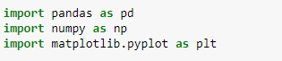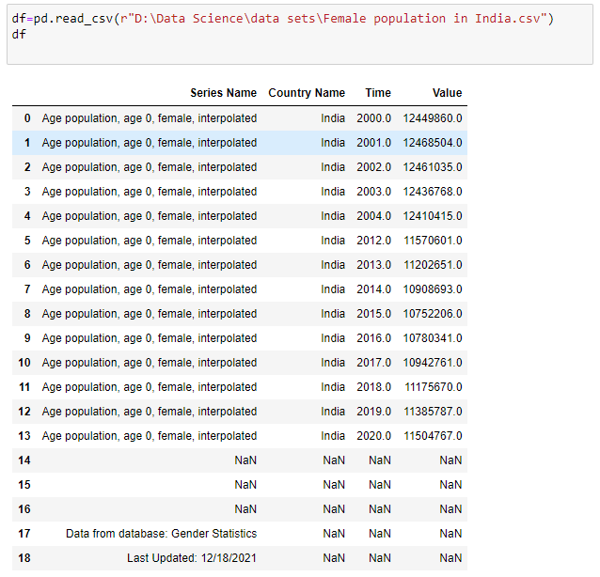
The next step is to check if the dataset has any empty values or noisy data and clean the dataset. We use the isnull() command to check if there are any null values in the dataset.
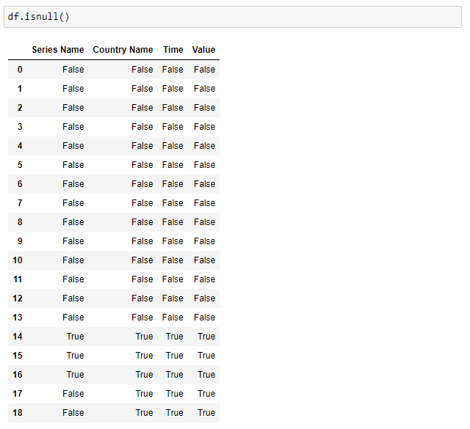
It is visible that there are empty values in the dataset. The next step in the process would be to clean the dataset and get rid of the empty values. We use the dropna() command to get rid of the empty values. At the same time, we are creating a new data frame with only the required values (since need the data from 2012 to 2020 for this visualization). We use the iloc command to get the data from 2012 to 2020. After we are done importing it into a new data frame, we print the data frame.
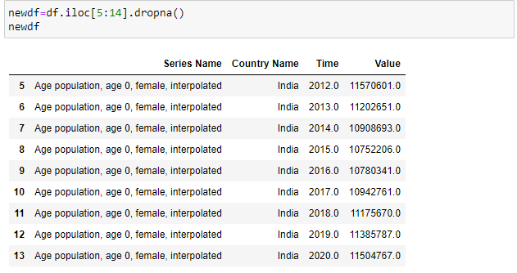
After printing the dataset, we can clearly see that there are incorrect data types. The year in the new data frame is in float and the value of the population is also in float. We need to change these values into integers so that plotting the graph becomes easier.
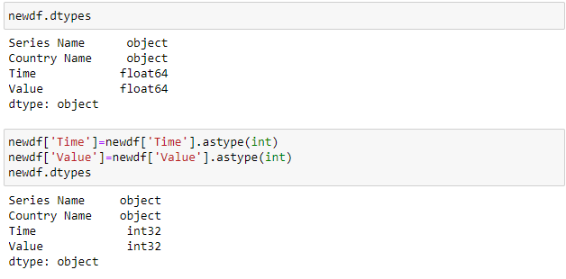
We print the data frame one more time to see if everything is accurate and then we move to plot.
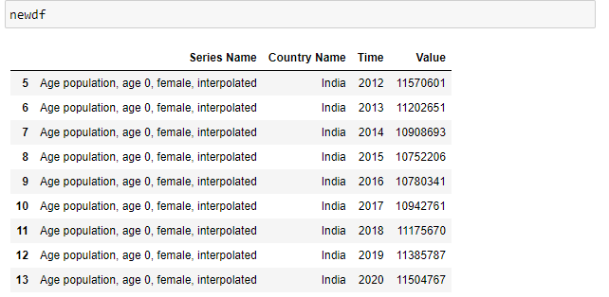
Everything is perfect with the dataset and we can move ahead to plotting. But before we plot, we need to import and clean the second data set (that is the data set with the male population metrics). We follow the same steps as above in cleaning and preprocessing the data.
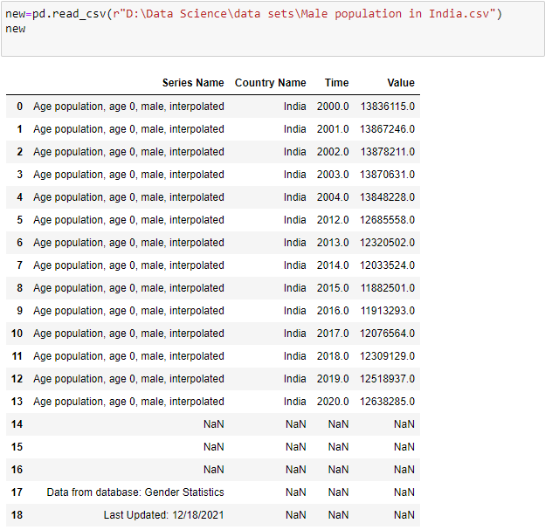
Checking for null values:
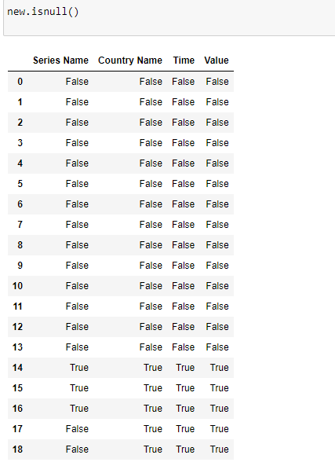
Cleaning the data and creating a new data frame:
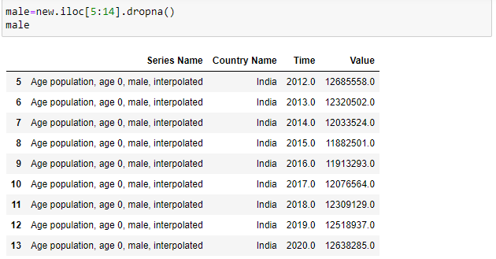
Checking the data types and correcting the data types: 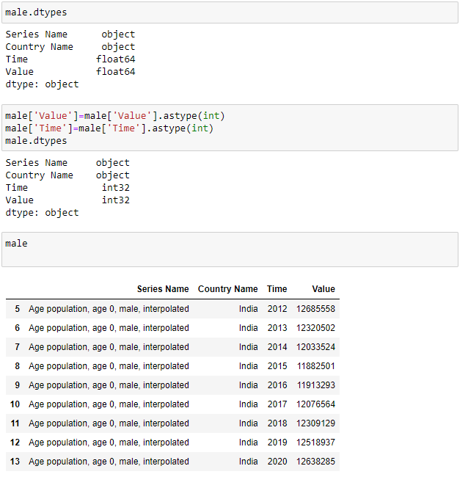
Now we have both the data frames that are required for plotting the graph. We are going to use the line graph to plot these data frames. We set the title, labels and also set the legend to the line graph. We start by setting the figure size of the graph. In this case, we are going to use a figure size of (12,8).
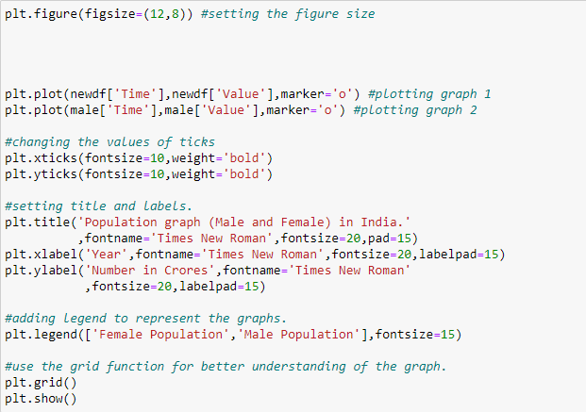
The final graph is as follows:
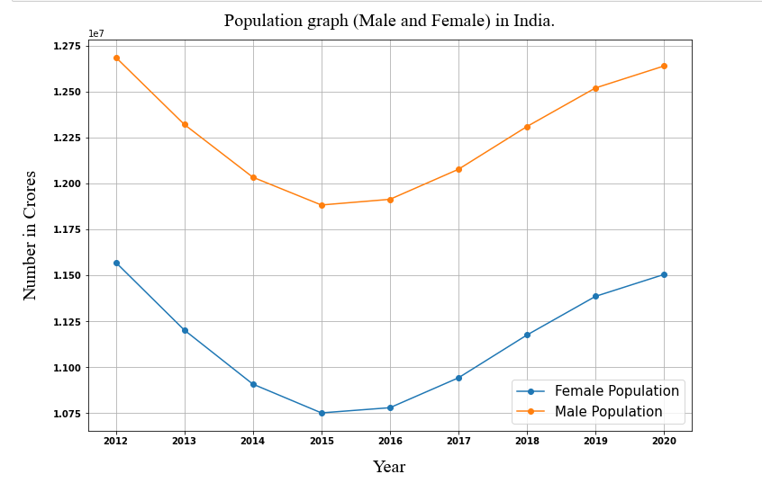
2.1.2 CONCLUSIONS:
The data was analyzed and it was evident from the graph that India has more male population compared to the female population from the year 2012-2020. The data was properly cleaned before it was analyzed. This graph shows that the gap between the male and female population needs to be taken care of before, it turns into a major problem.

